**InvoiceApp Assessment**

Please find below the screenshots I came up with when running the app on my local machine.

**H2 Console url**: <http://localhost:8080/h2-console/>

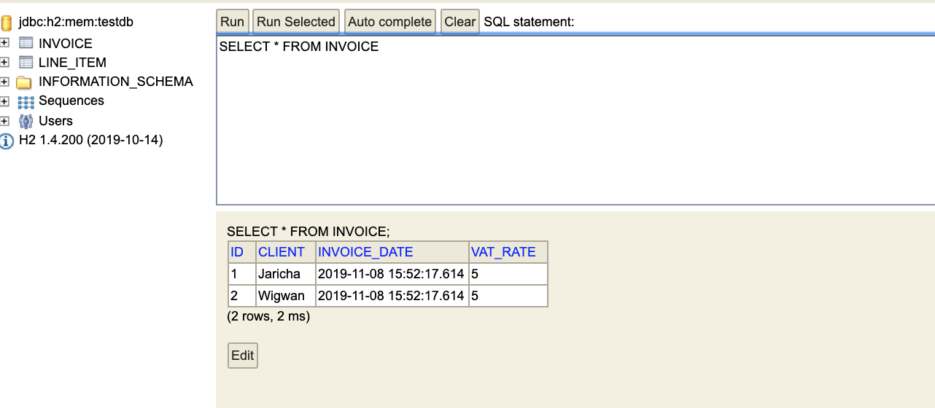

**Endpoints**

* Add Invoice 🡪 POST http://localhost:8080/invoices

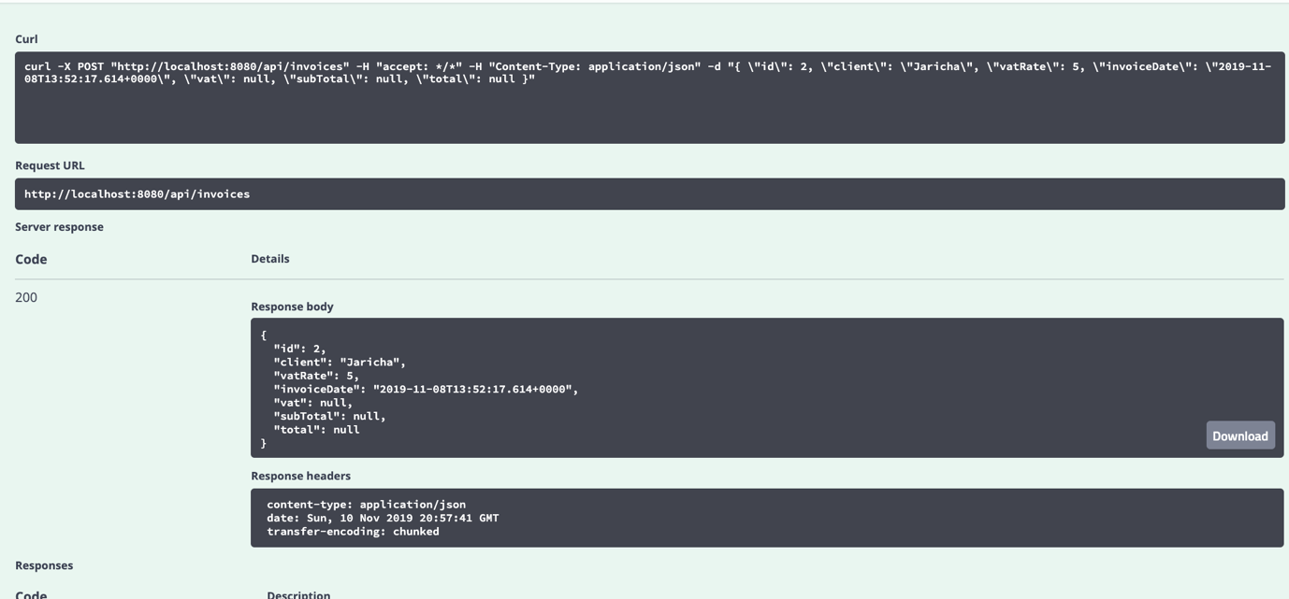

* View All invoices 🡪 GET http://localhost:8080/invoices

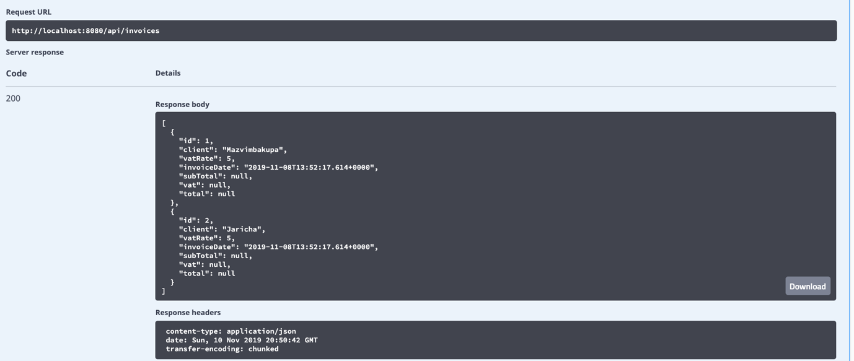

* View Invoice 🡪 GET http://localhost:8080/invoices/{invoiceId}

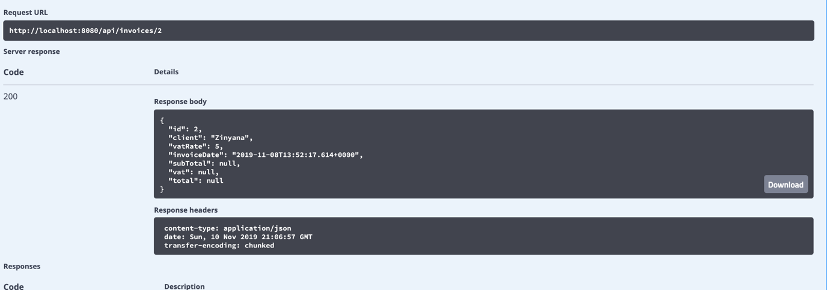

**Searching for a nonexistent invoice**

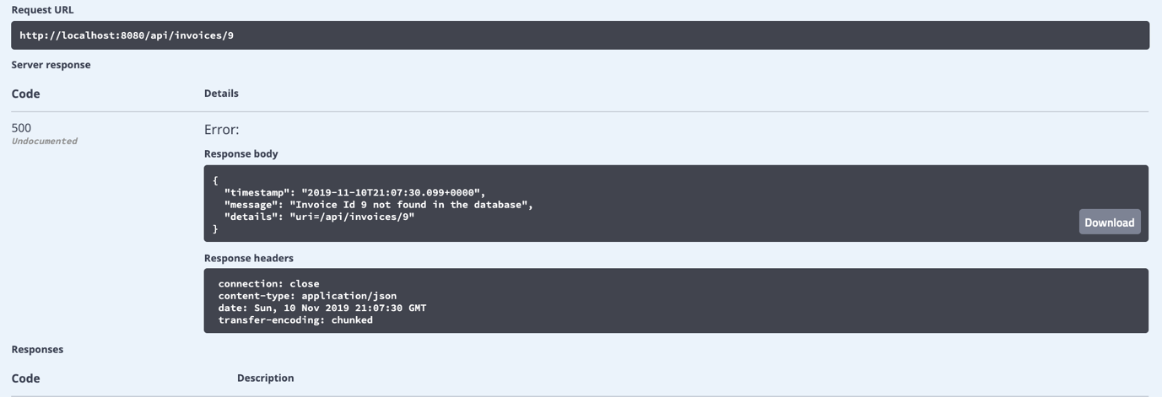

Swagger-ui url:

ocalhost:8080/swagger-ui.html